SURREY HILLS and MONT ALBERT PROGRESS ASSOCIATION INC (SHMAPA)
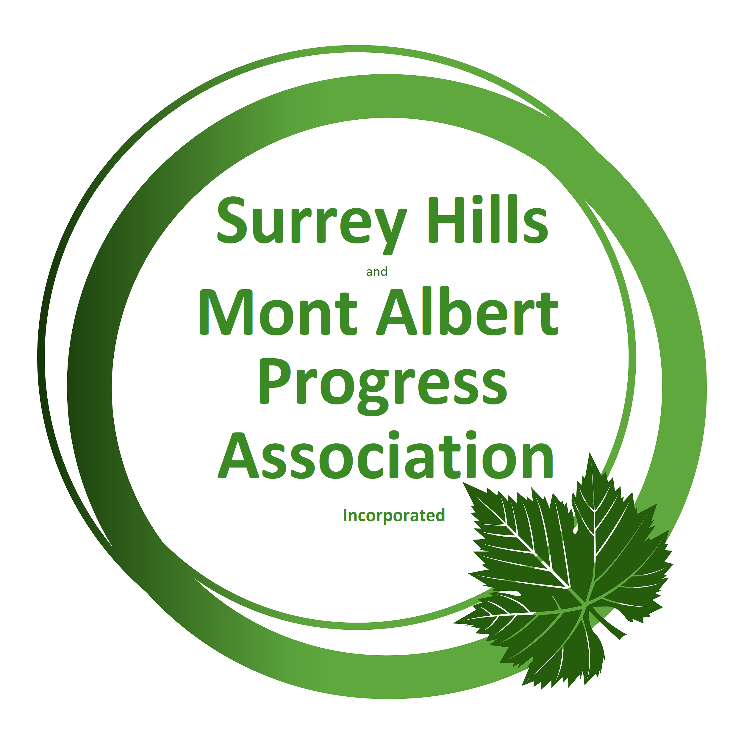
MEMBERSHIP APPLICATION / RENEWAL FORM
Membership for 2023-2024 financial year
(Fees are on an Annual basis and become due on 1 July)
I wish to renew/join SHMAPA on the basis of:
☐ Individual membership: $20.00 ☐ Family membership: $25.00
NB: Minutes and newsletters and most other communications will be distributed by email.
Individual/First person details:
First name: | Surname:
Email address:

Postal Address: | Post code:
Phone (H): | Mobile:
Do you have any special interests regarding joining SHMAPA?

For Family Membership – details of additional person(s) covered by this membership:
First name: | Surname:
Email address: |  | Phone:
First name: | Surname:
Email address: |  | Phone:

Are you a past member of SHPA, SHMAPA or WERA: ☐ Yes ☐ No
Payment can be made by:
☐ Cash ☐ Cheque ☐ Direct deposit
Direct Credit Details: BSB 633-000 Account 141152777 Bendigo Bank
On direct deposit please ensure you include [Your Surname] and the word MFees.
Cheques to Surrey Hills and Mont Albert Progress Association, PO Box 236 Mont Albert, Surrey Hills, 3127

